I. Housing Supply And Demand

To perform the regression analysis (with HPI as the response variable), a list of supply and demand variables was compiled. That is, these variables were determined to have an affect on the supply and demand of housing, respectively. Below are the variables:

A. Demand-side Variables
1.) 30-Year Current Coupon
One variable that was determined to potentially have effects on the demand for housing is the cost of credit, or the 30-year current coupon rate. The primary source for this data is the Fannie Mae and Freddie Mac agencies. The data is recorded monthly and is at the national level. The data was found using Bloomberg, and the commands used in the terminal are listed below.

<MCCN> Current Coupon
<MTGEFNCL> Fannie Mae 30 Year Coupon
<MTGEFHLM> Freddie Mac 30 Year Coupon

For the regression analysis, the Fannie Mae 30 Year Coupon rate was ultimately chosen. Shown below in Figure 1 is a time series plot of the 30-year current coupon rate. The series is plotted with data from December 1984 to February 2009, using monthly data.
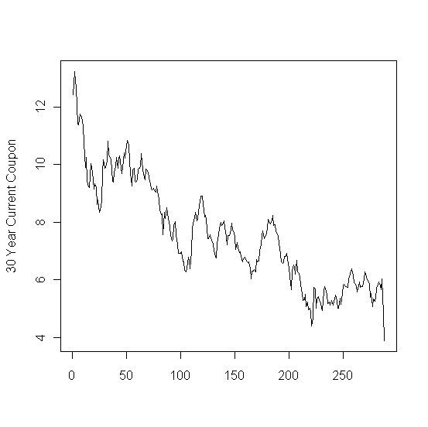
Figure 1: Time series plot of the Fannie Mae 30-year current coupon.

2.) Prime Rate
The prime rate is defined specifically as the average majority prime rate charged by banks on short-term loans to business, quoted on an investment basis. The average is computed by rates posted by a majority of top 25 (by assets in domestic offices) insured U.S.-chartered commercial banks. The prime rate is one of several base rates used by banks to price short-term business loans.
The bank prime loan rate was obtained from the Federal Reserve Board. The monthly rate is computed as averages of each calendar day in the month and are annualized using a 360-day year or bank interest.
Historical data is available from January 1949 until February 2009.

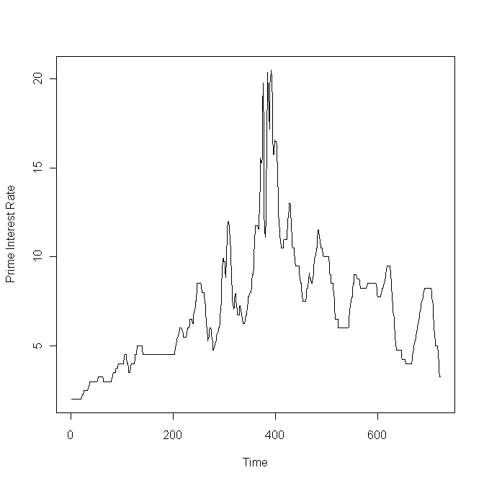
Figure 2: Time series plot of the prime interest rate.

3.) 30-Year Commitment Rate
This variable represents the rate that the secondary market secures to buy mortgages off primary mortgage originators. The agencies lock the originators into a yield for a certain period of time, obligating them to buy these mortgages off their books at a specified yield, for a specific period of time.

The 30-year commitment rate is available from the Fannie Mae and Freddie Mac agencies. The data is recorded monthly and is at the national level. This information was obtained from Bloomberg, and the following commands were used:

<FNCR3030> Fannie Mae Commitment Rate 30 Year 30 day
<FHCR3030> Freddie Mac Commitment Rate 30 Year 30 day

The rate obtained is also the same rate that is found in Section C of the Wall Street Journal under Secondary Markets, Freddie Mac and Fannie Mae 30 year mortgage yields. The commitment rate given by Fannie Mae was ultimately used in the analysis.

Below, Figure 3 shows the time series plot of the commitment rate from March 1983 to February 2009.
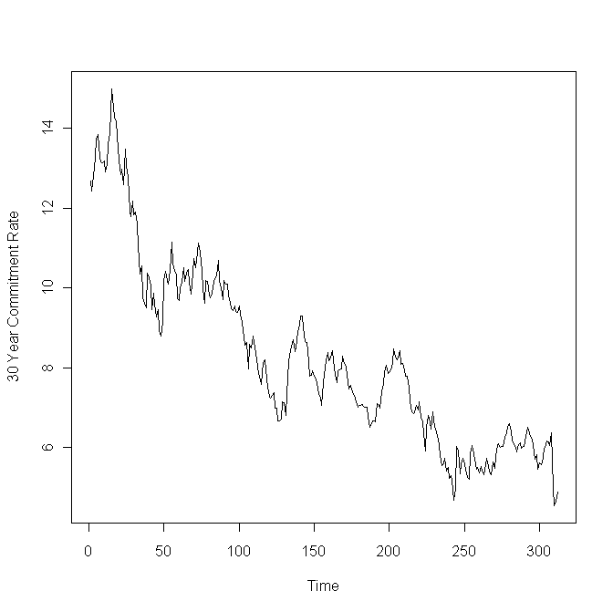
Figure 3: Time series plot of the Fannie Mae 30-year commitment rate.

4.) Population Size and Growth

Another factor predicted to have an effect on housing demand is the population size. The data was obtained from the U.S. Census Bureau, available on the website at www.census.gov. Population estimates were available yearly, starting from July 1900 to July 2008, both at the state and national level.

The time series plot of U.S. population size is shown in Figure 4. Additionally, the population growth is plotted in Figure 5.

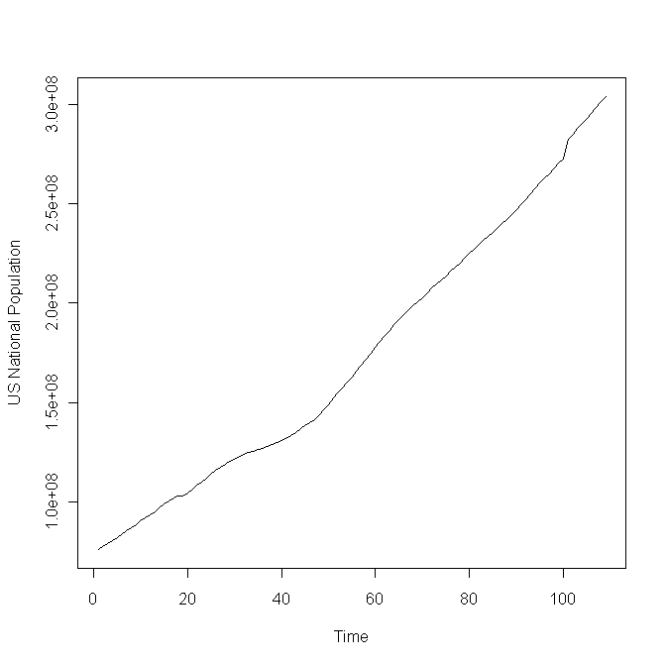
Figure 4: Time series plot of U.S. population.

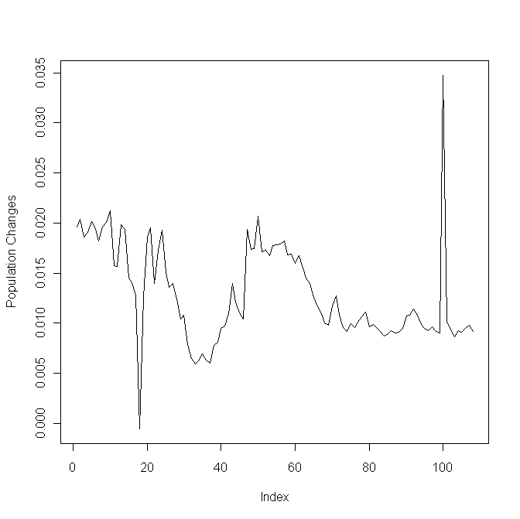
Figure 5: Time series plot of U.S. population growth.

http://federalreserve.gov/releases/h15/data/Monthly/H15_PRIME_NA.txt

